NAMA: Abi Ath Thaariq Rizalullah
NPM :2428240161
Link github: https://github.com/abiaththaariqrizalullah2428240161-tech/Abiaththaariqr_City_tour

Tangkap layer coding :
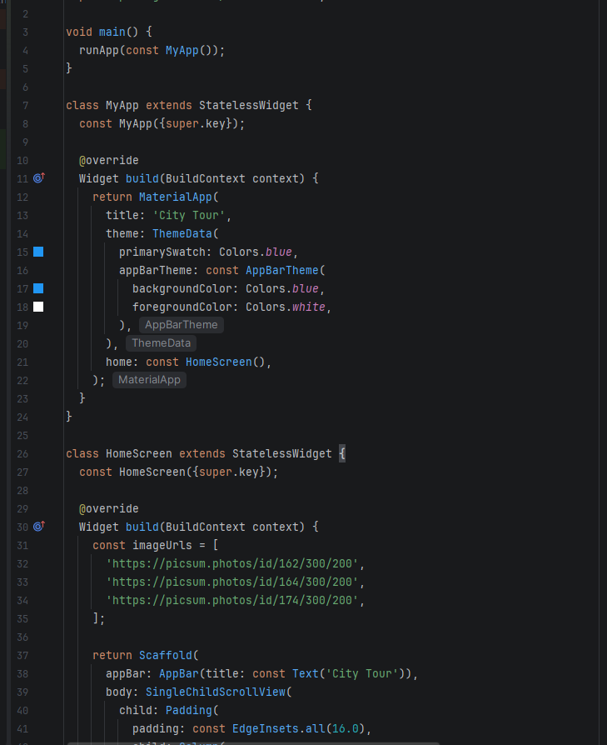
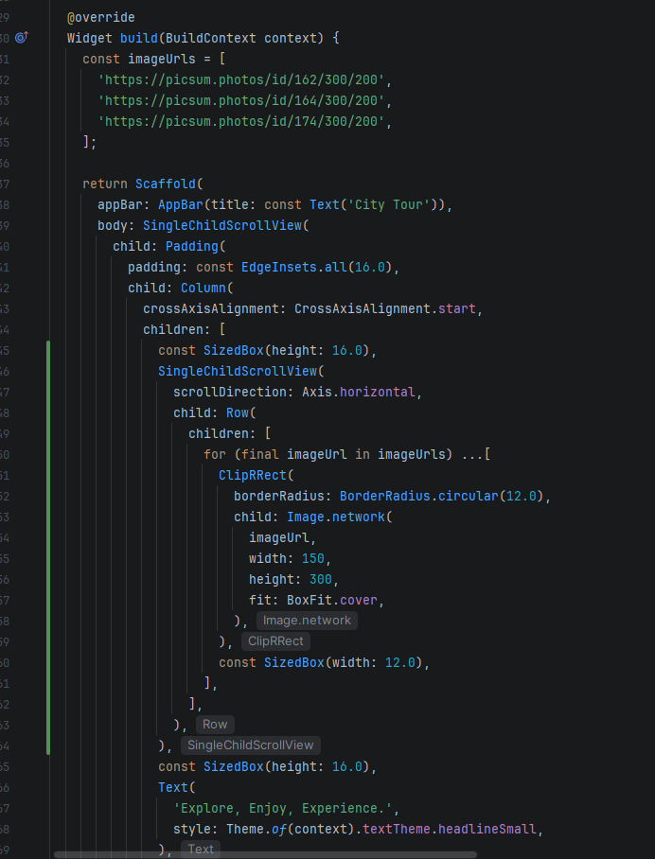
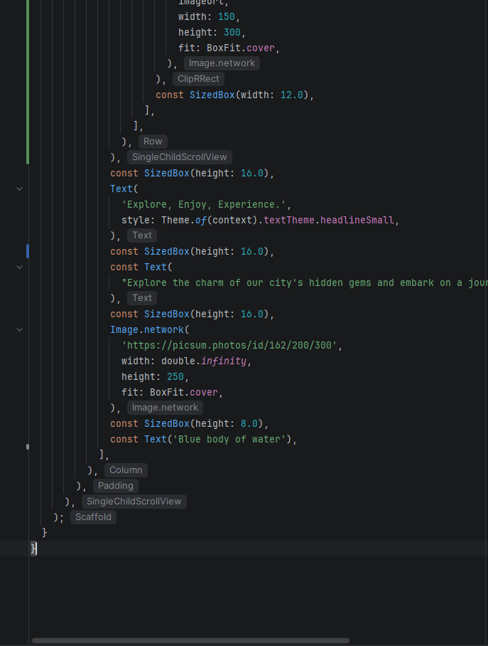

Tangkap layer program :


